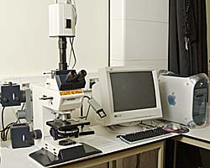 Term Project Part 2 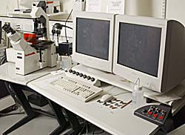

Knowledge is the fact or condition of knowing something with familiarity gained through experience or association. Knowledge arises through an acquaintance with or understanding of a science, art, or technique. Knowledge is the body of truth, information, and principles acquired by study, investigation, observation or experience. Is knowledge more important than skills? Well, skills are the ability to use one’s knowledge effectively and readily in execution of learned physical tasks. (Webster Dictionary) Knowledge you may forget but a skill you will never loose.
To reach personal achievement I will gain knowledge in biochemistry, medicine, pediatrics, international politics and as it relates to this course, computer programs and machine language. The skills I will obtain to be successful begins with solving mathematics equations, performing chemistry experiments, producing pharmaceuticals, childcare, learn multi-languages, and computer system operations. An information system is a type of work system that uses information technology- computer and communication hardware and software. Testing and augmenting substances relies heavily on technical equipment.
In today’s market it seems staying on top of the competition requires state-of-the-art innovations others cannot afford. However, price-performance is fundamental in maintaining reliable tools. Scalability, to increase the capacity of stored data, will be a necessity. Modularity is the theme; separating components to be developed, tested, and understood independently. Process modeling divides business processes into successively smaller subprocesses this strategy is consistent with the way successive decomposition divides programs into smaller subprograms. A technique programmers use to keep track of various parts of complex problems, organize ideas, and structured programming.
Computer-aided software engineering is the use of computerized tools to improve the efficiency, accuracy, and completeness of the process of analyzing, designing, developing, and maintaining an information system. To aid in chemical computation and visualization I will create a program for my personal computing on a laptop with help from (CASE). DBMSs for personal computers contain this capability. With ever increasing nonprocedurality, reusability, compilers, interpreters, and tighter links between analysis and programming, laws and formulas can be specified to develop solutions from inputted figures. I will also learn to debug logic or syntax errors and test the program. Unit testing treats the programs in isolation. System testing determines whether the entire computer system operates as intended. A main focus being confidentiality of lab results provided for by encryption coding, access restriction, and no user documentation. Interoperability will only be capable inside the laboratory with a semi-difficult user interface. Programming tools and languages affect managers and users.
“Information has the highest likelihood of making a difference if it its integrated into structured business processes and used by people with the knowledge and training needed to interpret it and apply it.” IS/IT knowledge and skills as my career progresses start with context of the environment pertinent to the field of discovery. Communication systems help people work together by interacting and sharing information in many different forms: teleconferencing, audio conferencing, audiographic conferencing, video conferencing, e-mail, voice mail, fax, unified messaging, instant messaging, and chat rooms. Intranets are private communication networks that are accessible only to authorized users. Extranets operate similar to intranets but are directed at customers. Groupware refers to software and related procedures that help dispersed teams communicate and control internal workflow, which will assist in international projects. Tacit knowledge-applied unconsciously and explicit knowledge-articulated formally is best exchanged through personal interactions. Knowledge management systems are designed to facilitate the sharing of knowledge rather than just information. Group support systems (GSS) supports communication by a specially outfitted conference room containing hardware and software that may include advanced presentation devices, computer access to databases, and capabilities permitting participants to communicate electronically and anonymously for analyzing data and building models. Office automation systems (OAS) use a wide range of everyday information processing tools such as spreadsheets, word processors, and presentation systems to process personal and business data.

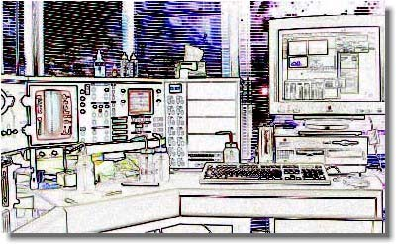Evaluation of the process’ performance includes quality, accessibility, presentation, and security of information, whereas skills, involvement, commitment, and job satisfaction are important for participants. Product design systems are the first step in creating value for the customer. Designing a product or service based on the customer’s desires, the designer(s)’ envision, and the firm’s goals and capabilities. Visual capabilities in advanced computer-aided design (CAD) software systems accept descriptions of components or processes and can display the resulting product specification graphically. A crucial management responsibility is to identify ways to do work more efficiently, to produce effective products and services for both external and internal customers, select an adequate technical and human infrastructure for an exceptional work system by defining the problem and the work system. The work system framework clarifies what system is being discussed, how well it is operating, and how it might be improved. Supply chain systems start with information about what inventory is available, when previously ordered material will arrive, and when materials will be needed based on forecasts. Supply chain management (SCM) systems standardized and automated both internal data processing and data transfer between suppliers and their customers because this makes procurement systems faster. Material requirement planning (MRP) systems integrate purchasing and production activities. Through the use of electronic data interchange (EDI), the electronic transmission of business data from one firm’s computerized information system to that of another firm, check for availability and respond quickly. Combining computerized data collection and integrated data flows between design, manufacturing, planning, accounting, and other business functions, computer-integrated manufacturing (CIM) is now a reality due to increased computer power at much lower costs, better data management capabilities and distributed computing and telecommunications. CIM provides reduced costs, better quality, better customer service, greater flexibility responding to customer requirements, and quicker time-to-market of new products. The value chain includes primary processes that directly create the value the firm’s customers experience and support processes that add value indirectly by making it easier for participants to perform the primary processes.
E-commerce has become a lucrative strategy in the trend toward e-business. Direct marketing and sales combines POS (point-of-sale) systems data and other data related to subscriptions, personal affiliations, and Web usage to indicate preferences and buying patterns linked to individuals. Customer relationship management (CRM) is the collection of customer interaction data potentially useful in crafting marketing campaigns and building targeted sales. Transaction processing systems (TPS) record data about transactions and sometimes control decisions made in part of transactions. Management information systems (MIS) and Executive information systems (EIS) convert TPS data into information for monitoring performance and managing an organization; provide executives information in a readily accessible interactive format. Managers, analysts, and other professionals use a decision support system (DSS) with user-controllable methods for displaying and analyzing data to help make decisions.
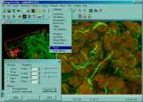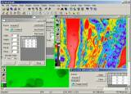
With time there is change. A lot of us want promotions in the careers we’re in. After I graduate I will gain experience through an entry-level job at a research institute. Then, advance to facilitation coordinator or begin my own research project. My ventures will take place overseas and gain wide spread recognition. I’ll discover something extraordinary and have the patent to produce it. I’ll earn a ton of money and become a philanthropist and politician.

Bioinformatics LaboratoryManaging and exploiting biological data
SUN hierarchical data storage system
UNIX (Linux) high performance computing
Access to the White Rose Computational Grid
Nucleic Acids LaboratoryGenomic Analysis
Affymetrix gene array system (internal users only)
Sequencing and Genotyping (internal users only) - Beckman CEQ DNA (Microsatellites, AFLPs, SNPs)
Custom gene array production and scanning
Real-time (quantitative PCR)
Agilent 2100 bioanalyzer (internal users only)
Protein Production LaboratoryOverexpression, fermentation and purification
7 litre glass fermenters
20 litre stainless steel fermenter
Bacterial, yeast, insect and mammalian systems
Pharmacia Akta Prime purification system
Pharmacia Akta Prime Purifiers (10 and 100)
Over-expression cassettes
Molecular Interactions LaboratoryProtein functional behaviour
Analytical ultracentrifuges (absorption and interference optics)
Circular dichroism spectrophotometer
Fluorescence and UV/VIS spectrophotometers
Protein-protein mass spectrometer
Surface plasmon resonance
Rapid reaction equipment
Isothermal Titration Calorimeter
Imaging and Cytometry LaboratoryCell Structure, Function and Dynamics
Confocal microscopes
Fluorescence microscopes
Electron microscopes (SEM and TEM)
Flow cytometry (analysis and sorting)
Laser capture microdissection
Image analysis software
Sample preparation.

The classic proteomics method uses 2DE to separate proteins. The identities of proteins in individual spots from the gel are then identified by mass spectrometry of their tryptic peptides.
Shotgun methods provide a powerful alternative to gels. Proteins are first digested with proteases into a more complex peptide mixture that is then analyzed directly by MDLC-MS. 2DE-based workflows are suitable for soluble proteins, but not for membrane proteins, because of problems with IEF of hydrophobic, detergent-solubilized proteins. Shotgun methods do not rely on IEF and are therefore better suited for membrane proteins.
A hybrid workflow, Gel-C-MS/MS, uses 1D SDS-PAGE and LC-MS. Gel-C-MS/MS does not have the limitations of 2DE or the difficulty of MDLC, and could become the method of choice for many applications.

Applied Biosystems 4700 Proteomics Analyzer
- MALDI-TOF/TOF™ tandem mass spectrometer
- High energy CID-MS/MS
- Very high throughput
- Automated batch data acquisition and Mascot searching
- LC-MALDI using Ultimate HPLC and Probot fraction collector
Applied Biosystems QSTAR Pulsar i
- Quadruple-Time-of-Flight tandem mass spectrometer
- ES-LC-MS and MDLC-MS
- Protana nanospray source
- TurboIon Spray source
- APCI ion source
- ProICAT software
Dionex LCPackings Ultimate
- Capillary nanoLC
- Famos autosampler
- Dual-valve, MDLC-capable
- UV detector
Spectro Ciros CCD ICP-OES
PelkinElmer Autosystem GC
Dionex BioLC
Dionex LC Packings Probot
Agilent 1100 HPLC
Packard MultiProbe II Robot
Bio-Rad Protean II
Bio-Rad Protean IEF
Bio-Rad Molecular Imager FX
Bio-Rad VersaDoc
Nonliner Dynamics Phoretix 2D Evolution
Applied Biosystems 4700 Proteomics Analyzer. This MALDI -TOF/TOF™ tandem mass spectrometer is unrivalled for the identification of proteins from tryptic digests, because of its sensitivity and speed. High-speed batch data acquisition is coupled to automated database searching using a locally-running copy of the Mascot search engine.
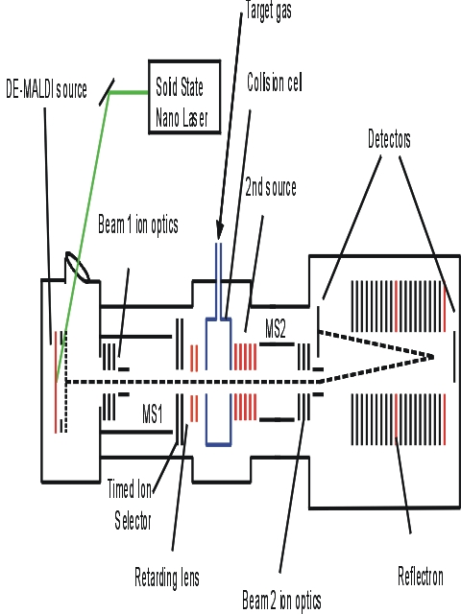

Flow Cytometry involves the use of a beam of laser light projected through a liquid stream that contains cells, or other particles, which when struck by the focussed light give out signals which are picked up by detectors. These signals are then converted for computer storage and data analysis, and can provide information about various cellular properties.

Transgenic and targeted gene disruption models provide powerful approaches for the study of gene function in relation to normal biology and disease, and the development of murine models for the study of molecular toxicology and molecular biology has become an integral part of modern biological research.
Major equipment includes a Leica microscope with dual micromanipulators, a Sutter programmable pipette puller, a Narashige microforge, an Olympus dissecting stereoscope, an Eppendorf microinjection system, a laminar flow hood, and incubators.

Equipment The laboratory currently includes:
  - BD FACStar Plus with dual ion lasers, dye laser, pulse processing and 7th active detector
  - BD FACScan with pulse area/width processing
  - BD LSR 3-laser 6-color analytical flow cytometer
  - API DeltaVision Restoration microscopy system
  - Perkin-Elmer HTS1000 Plus fluorescence microplate reader
  - Molecular Dynamics Phosphorimager 425S
  - Molecular Dynamics Typhoon 8600 variable mode imager
  - Zeiss inverted microscope with color analog/digital image capture
Data acquisition and analysis is performed on a variety of computers:
  - Power Macintosh
  - PCs running Windows
  - PCs running Linux
  - SGI MIPS workstations
  - Sun SPARCStation 2
Software The following software is available for data processing:
  - Becton-Dickinson CellQuest 3.3
  - Becton-Dickinson CellQuest Pro
  - Sundisplay (Joe Trotter)
  - WinMDI (Joe Trotter)
  - MultiCycle (Phoenix Flow Systems)
  - Modfit (Verity)
  - softWoRx deconvolution software (Applied Precision)
  - ImagePro Plus (Media Cybernetics)
  - NIH Image
  - GIMP, Photoshop, Canvas (Various)
  - ImageQuant for Mac and PC (Molecular Dynamics)
  - HTSoft (Perkin-Elmer)

