Lesson 9 – Palm reading…

I hope you all had fun playing Twinkle, Twinkle Little Star last time. If you’re to the point where it actually sounds like the song, then congratulations, you’re ready to play a real song.

Now before I throw the tab up for you, we have to talk about something. Palm muting is an effect that makes a note or chord sound slightly muted.

To pull off this effect you have to lay the pinky-side of your right hand slightly over the strings of the guitar where they connect to the bridge.
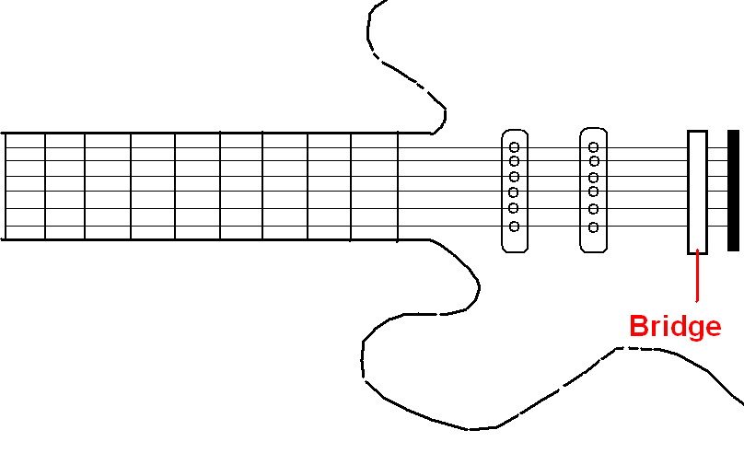
By letting the side of your right hand lightly touch the strings at the bridge, you should still be able to flick your wrist and strum. If you’re holding G5 (power G) with your left hand, you should hear the G-chord sound, but it should be a little muted. Try alternating between muted and normal for practice. Remember to turn on your distortion. Distortion pedals and palm muting go together like peanut butter and jelly. Mmmmm…

I hope you remember Twinkle, Twinkle because you’re gonna try it with palm mutes now. But the timing on the chords will be a little different.

Originally it was:

Count: 1 2 3 4 1 2 3
Words: Twin - kle Twin - kle lit - tle star

Now the count will be more like this:

Count: 1 2 3 1 2 3 1 2 3 1
Words: Twin - kle Twin - kle lit - tle star

The 1’s will be normal power chords. The 2’s and 3’s will be palm-muted.

Here’s the tab:
e ----------------------------------------------------------------------------------------------------
b ----------------------------------------------------------------------------------------------------
g -------------------------7----7--7----------------9----9--9-----------7--------------------------
d ---5------5--5----------7----7--7---------------9----9--9-----------7--------------------------
a ---5------5--5----------5----5--5---------------7----7--7-----------5--------------------------
E ---3------3--3------------------------------------------------------------------------------------
Twin - kle, Twin - kle lit - tle star
PM PM PM

e -----------------------------------------------------------------------------------------------------
b -----------------------------------------------------------------------------------------------------
g ---5------5--5----------4-----4--4----------------------------------------------------------------
d ---5------5--5----------4-----4--4---------------7------7--7-----------5-------------------------
a ---3------3--3----------2-----2--2---------------7------7--7-----------5-------------------------
E ---------------------------------------------------5------5--5-----------3-------------------------
How I won - der what you are
PM PM PM

e -----------------------------------------------------------------------------------------------------
b -----------------------------------------------------------------------------------------------------
g ----7-----7--7---------5----5--5----------4-------4--4------------------------------------------
d ----7-----7--7---------5----5--5----------4-------4--4--------7--------------------------------
a ----5-----5--5---------3----3--3----------2-------2--2--------7--------------------------------
E ------------------------------------------------------------------5--------------------------------
Up a - bove the world so high
PM PM PM

e ----------------------------------------------------------------------------------------------------
b ----------------------------------------------------------------------------------------------------
g ----7----7--7--------5------5--5--------------4-----4--4----------------------------------------
d ----7----7--7--------5------5--5--------------4-----4--4-------------7-------------------------
a ----5----5--5--------3------3--3--------------2-----2--2-------------7-------------------------
E -------------------------------------------------------------------------5-------------------------
Like a dia - mond in the sky
PM PM PM

e ----------------------------------------------------------------------------------------------------
b ----------------------------------------------------------------------------------------------------
g -------------------------7----7--7----------------9----9--9-----------7--------------------------
d ---5------5--5----------7----7--7---------------9----9--9-----------7--------------------------
a ---5------5--5----------5----5--5---------------7----7--7-----------5--------------------------
E ---3------3--3------------------------------------------------------------------------------------
Twin - kle, Twin - kle lit - tle star
PM PM PM

e -----------------------------------------------------------------------------------------------------
b -----------------------------------------------------------------------------------------------------
g ---5------5--5----------4-----4--4----------------------------------------------------------------
d ---5------5--5----------4-----4--4---------------7-----7--7-----------5-------------------------
a ---3------3--3----------2-----2--2---------------7------7--7----------5-------------------------
E ---------------------------------------------------5------5--5-----------3-------------------------
How I won - der what you are
PM PM PM

The PM’s denote palm-muting. In this case the palm muting is the two chords that line up with the PM’s. If you played the version in lesson 8, you can just substitute two palm mutes for every time you see a second chord.

If you still don’t get palm mutes, go on to the next lesson. But try and get it going here. It’ll pay off in the long run.

Homework
- know the terms: Palm Mute, Bridge
- Practice playing the new version of twinkle, twinkle * *Good Palm Muting Technique Is CRITICAL to rock guitar**

