Lesson 1- This is a guitar…

Alrighty, I’m gonna start things off slow. If you know this stuff already, bear with me (or skip ahead) because I have to start at the beginning…

This is a Guitar:
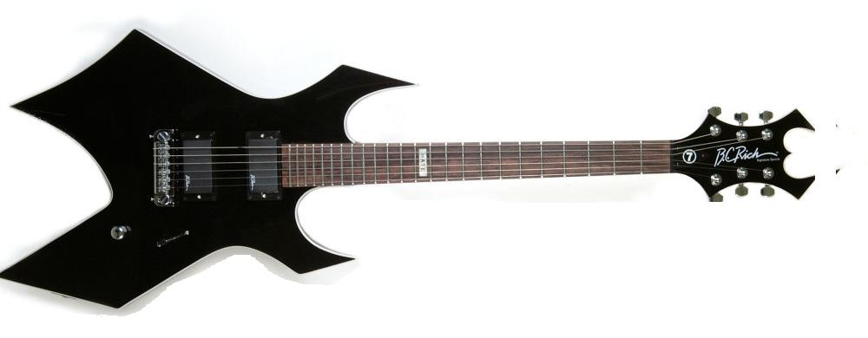

Yours (you do have one right? If not, GO GET ONE!!) may not look like this, but they both have something important to this lesson: STRINGS!

There are 6 strings on a standard guitar, and they are all of different thicknesses. The thicker strings give lower notes, and the thinner the strings give higher notes. Here are the 6 strings from thickest (bottom) to thinnest (top):

e-------------------------------------------------------------------------------------------------------
b-------------------------------------------------------------------------------------------------------
g-------------------------------------------------------------------------------------------------------
d-------------------------------------------------------------------------------------------------------
a-------------------------------------------------------------------------------------------------------
E-------------------------------------------------------------------------------------------------------

You can see the strings like this if you look down at your guitar while holding it (remember to hold the neck in your left hand and strum with your right hand, assuming you’re right-handed). The big “E” should be the thickest string.

You should try to be familiar with the names of the strings. Memorize which is which, it’ll be important. The name of the string is the note that it plays when you pluck it.

There are 7 main notes in music: A B C D E F G
They repeat over and over again: A B C D E F G A B C D E F G A B C D E F G
The 8 notes from one letter to the same letter further down, is an octave:
A B C D E F G A B C D E F G A B C D E F G
Or
A B C D E F G A B C D E F G A B C D E F G

Think of it like this: You’ve heard of “do re mi fa so la ti do”. Well, the do’s at either end make that and octave.

One last thing for this lesson: There are other notes between the ones we talked about. These are called “sharps” and “flats” and are marked “#” (sharp) and “b” (flat). For example, C# is “C sharp”. A sharp is between the note it names and the next higher note, a Flat is between the note it names and the next lower note. Here are all the notes in an octave from A to A:

A (Bb) B C (C#) D (Eb) E F (F#) G (Ab) A

Note 2 things, first, some of these can be called by 2 names. For instance, Ab could also be G#. They are the same note, but Ab is usually used. Likewise, C# and Db are the same note, etc. Second, there are no notes between B&C and between F&G. That is simply how musical notes work. If you were to see a piano with the keys marked, you could see this:

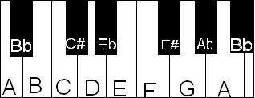

look familiar? It’s the same as the listed notes from before: A (Bb) B C etc….

You can see that B&C and F&G are next to one another.

Homework
Before going on to lesson 2, you should know:
- The letters of the 6 strings (not just the letters, but which string is which)
- Understand the words “octave”, “sharp”, and “flat”.

