Group 3
Molly Howell
Ross Hedvicek
Jason McMillan
Matt Carpenter
Sven Hahues

Software Engineering – FGCU Alumni Website

This is the final report for the FGCU Alumni page project. It includes all the information that were in the previous reports as well as a section that discusses the actual project implementation and the outcomes of this project.

Description of the project:
The FGCU Alumni Website will allow people who graduate from Florida Gulf Coast University to keep in touch with people who they went to school with. Furthermore it will be a place to post news about ongoing and upcoming events of FGCU alumni, and a place for them to interact with each other, as well as keep in touch.
In addition, the website will allow the departments and alumni to post job opportunities for other alumni to see. Furthermore, there will be a suggestion part of the website, where alumni can submit suggestions, such as university sponsored get together, to the university. The users will be able to create an account with a password that they will use to log into the system. Once there they can fill out their contact information and share whatever they would like to with other alumni to protect their privacy. The users’ information will not be used for any kind of commercial use, they will strictly be used for the alumni association.

Purpose of the project:
The purpose of this project is to create a small community where FGCU alumni can reunite, share information and look at job opportunities.

Current System:
Right now there is no system in place for this. A list of all the graduates from a department is held at the department, and if there are events within that particular department, the department will contact their alumni themselves.

Problem Statement:
There is no central place for FGCU graduates to go right now. After graduation, graduates have no way to keep in touch with old classmates, other than the information they have themselves. The ways of organizing events right now are hazy and it is hard to reach out to every alumni.
Furthermore, departments such as the College of Business, only maintain records of their own graduates, so if there were to be a get together of all alumni, sponsored by the CoB, it would be very time consuming for them to get in touch with every alumni from every department. In addition, there is no way for the University to easily get in touch with every alumni that ever went to school there, which makes building a culture and sense of community and belonging harder for the university.

Scope:
- Description:
Create an easy to use website for FGCU graduates, to have a place to share information on where they are, how they are doing and listing of possible job offers.
- Benefits:
Improved communication between alumni and faculty
Inexpensive implementation
Improved time efficiency of information distribution compared to the current system
Combination of several manual tasks into one central location
- Duration of the project:
The final project will be handed in on December 5, 2002

Systems Development Lifecycle to be used:
We will be using the incremental Waterfall approach. Our reason for doing this is, that we will do several small steps until the project is completed. It will be much more manageable and easier to handle this way. At first we will start with the server setup then the database design and then start with the actual coding of the website.

Technology used:
The website will be hosted on an “apache” web server running Red Hat Linux v7.3. The database we will use for this system is PostgreSQL, a open source database that is included in this distribution of Linux.. The reasons for running Red Hat are: discovery of a new operating system, use of a web programming language other than ASP (PHP will be the programming language that we will use), Linux and PostgreSQL are free, so there will be no added software cost to this project. It will be hosted on a privately built server until completion at which time the university will take over the project.
The reason for using PostgreSQL over MySQL is that PostgreSQL is a little bit more scalable towards supporting more users. It is slightly slower than MySQL, but it supports more users that are simultaneously logging into the database.
All our team members have done Web programming before, which is the primary reason we choose this project. Furthermore the setup and administration of a web server will be done by us for the time being. The server was accessible to all team members at most times of the day.

Business Constraints:
There will not be many constraints. Not all of us have used PHP as a programming language, nor are all of the users familiar with Postgres and Linux, yet we are confident that we can overcome this, and learn both these in a relative short time. The budget of this undertaking is negligible, as all the software is free and the server was built out of old computer parts.

Possible Conflicts among stakeholders:
If not done to university standards the system itself will fail, as the university will very likely reject the use of it.

Users and Owners of the system:
The primary users of the alumni page will be all the alumni who graduated from FGCU, and the faculty and staff who instructed these students. The system will be administrated by a person who volunteers to take the time to update the news and events on this page. The administrator also has access to all the user information and can modify them if they see need. The administrator also has the right to delete user accounts. The University will be the owner of the system once it is completed and accepted.

Cost - Benefit analysis:
The costs of this project will be minimal, as it will be run on Linux, using an open source database and PHP to access the database. Once completed, the system should not need a lot of maintenance.
The benefits of the website far outweigh the costs, as this will be perceived as an effort to build a community of alumni. The benefits can range anywhere from a good culture among the graduates of FGCU to donations for alumni programs and events.

Milestones:
All milestones are detailed in the task assignment. Significant milestones are as following:
September 19, 2002 - Final Plan
October 3, 2002 - Update of System Analysis
October 25, 2002 - Update of System Design
November 11, 2002 - Update of Implementation Process
December 5, 2002 - Completion of Project

Business Rules:
The business rules we decided to use were the kinds of users we will have for this website. Depending on the status of the user, they will have different permission on the website. We identified three groups of possible users.

- Unregistered user/registered user who is not logged in
Users of this class can either create a new account or log in so they can move to the second kind of users, which will be discussed next. These kinds of users will be able to browse the Alumni website and submit suggestions, as well as search for job information and other Alumni.
- Registered user who is logged in
Registered users that are signed into the alumni page have all the right unregistered users have, except the site offers more functionality to them. If they searched for other alumni, they can now send an email to other alumni through the alumni website, to protect the email address of other alumni. Furthermore, they can fill out their personal information, so that other alumni can find them when searching through the list of alumni. While filling out their personal information the alumni has the ability to hide their personal information from being displayed in the search result. If the alumni choose to hide his or her personal information, only the year of graduation, major and current state will be displayed along with their last name and first name. Once the personal information are entered, the user can go back and edit them whenever they see fit. They will also have the ability to post jobs that will be sent to the administration for review and then possible posting. Finally, if this kind of user decides to submit a suggestion using the suggestion box, their personal information will be filled in based on availability; at least the email address will be supplied since it is required during signup.
- Administrator
The administrator to the site has all the functionalities of the other 2 sets of users, and more. Administrators will be able to see all the suggestions sent through the suggestion box, they will see all the job information submitted, and they will have access to any users personal information, the ability to edit and change these as they see fit, the ability to add/remove news and events to the site as well as deleting users from the database.

Process Diagrams:
The purpose of these diagrams is to model the flow of data through the system’s major processes. The following three diagrams give an example of what a user can do when they are not a registered member of the alumni page and they can do when they are a registered member.

Example 1 – Unregistered Member:
If the user decides not to log in, they will have the option of searching for other Alumni. At the search page they will be asked to enter information about the Alumni they are looking for, these information can be, major, year of graduation, last name, first name or maiden name in case that specific person may have gotten married since they graduated. The submitted information will then be checked against the database and the information will be displayed on a results page.
If the user decides to browse through the jobs that are available they can do that in much of the same fashion that they used to search for other Alumni. Once again, the user will be asked what job field they are interested in, and those information will be checked against the database, and results based on the query will be displayed on the page.
Moreover, the user will also be able to send suggestions to the administration. This part is not covered in the diagram, but explained here for clarification. Any user of the website will be able to send a suggestion through the “Suggestion Box” feature of the site. This is done by filling out a form on the Suggestion Box part of the page which requires the user to leave their first name, last name and email address, so that they can be gotten in contact with in case there is need. The suggestions will be displayed on an administrative part of the page that only the administrator of the site has access to. The administrator can then make a decision on what to do with the suggestions, and forward them to the appropriate people.
An unregistered member of the Alumni page will be able to create a User Account to log into the Alumni Page to take advantage of its full capability. The process of signing up as a new member, asks the user for a username and password, as well as an e-mail address. Upon entering the data, the information will be checked for validity, and the username will be checked against other member names to make sure there is no duplication of this. If the data check is complete and there are no complications, the user information is stored in the database, and can then be used to log into the actual website.

Example 2 – User is registered and logged in
Once the user has created an account they can log in. Logging in will give the user another set of options that can not be seen by users who are not logged on. The user will have all access rights an unregistered user has and the added features they can from registering.
The user will now have the chance to enter their personal information. The personal information consist of first name, last name, address, employer, current job held, e-mail address (though required for account creation, e-mail address can change like street addresses and are therefore included again), major or date of graduation. This page also allows the user to choose if they want to keep their personal information private from other users. For the user’s convenience, once the information is filled in, upon subsequent return to the page, all information, except the password will be filled in for them. Once all the information is entered into the form, it is submitted and stored in the database.
In addition to the regular search feature, users who are currently logged in, will have the ability to send other registered Alumni e-mail through the website. The website will automatically fill in their e-mail address, and hide the intended recipient’s email address for further protection of privacy. The mail will then be sent through the web servers e-mail capability and received by the other party just like normal email.

Example 3 – User is registered and logged in
This diagram illustrates that a logged in user has the ability to enter job opportunities. This will be done via another form that is only accessible to logged in members, who will send the information about a job to the administrator who will then make it available to all users. This is done so that no one can post bogus job information and to keep things organized. It will be the administrator’s responsibility to reply to the user who offered the job, and acquire additional information about the job.

Example 4 – Administrator
The administrator of the site has even more functionality than any other kind of user. Once the administrator enters the administrative area of the alumni page, they will have the ability to update any users’ record, as well as delete users’ records, in case there has been abuse of the site by someone and that user shall have his account revoked. In addition to that, the administrator will have an area of the page where they will be able to view all the suggestions that were sent through the suggestion box. If any of these suggestions warrant action, such as a post in the news section, or an e-mail forward to another FGCU faculty member, it is the administrator’s responsibility to take the necessary actions. Finally, the administrator can post news and events that will be displayed for all users. To do so the admin will simply go to the post news and event section of the website and fill out the form that will automatically post the news on the website.

Other Design Documentation:
Other documentation that is used to a great extend of this project are the Florida Gulf Coast University Web guidelines that are a requirement for any website that will be officially hosted by FGCU. The only change we made to these policies is the exclusion of a text-only site. We are in touch with David Jaeger, who is in charge of the FGCU web development, and he gives us feedback on what we need to change to make the site compliant with FGCU standards. A copy of all the web policies can be viewed online at: http://itech.fgcu.edu/web-policies.asp

User Interfaces:
The layouts were done following the Florida Gulf Coast University web design policies that we covered in the “Other design documentation” part of this report. The layouts were done using Dreamweaver MX and were converted into PHP pages. The layouts can be found on the CD that was handed in with this project.

Database Design:
The design process of the database followed the completion of the layouts of the website. We drafted a data dictionary, revised it and built and Entity Relationship Diagram (ERD) based on the layouts and the data dictionary. The purpose of the ERD is to make a graphical representation of the entities, and the relationships between entities, within an information system. Please see the attached ERD for reference.

Data Dictionary:
To aid in the design process of the ERD we decided to make a data dictionary which contains information about every entity in the system, as well as the entities attributes and information on those attributes. Please see the attached data dictionary for reference.

PHP Server Interaction:
PHP or “PHP: Hypertext Preprocessor” is an open source, platform independent web programming language. PHP is an alternative to Microsoft's Active Server Page (ASP) technology. As with ASP, the PHP script is embedded within a Web page along with its HTML. Before the page is sent to a user that has requested it, the Web server calls PHP to interpret and perform the operations called in the PHP script. We chose PHP primarily for its platform independency and the fact that it would give us another language we could learn and benefit from; furthermore most of us had some basic knowledge of ASP as a Web programming tool and felt that it was not out best choice to use it for this project, due to its slowness in larger operations that would require many accesses within a given time. Moreover, since we decided to run this Website off an Apache Web server that is hosted on a Linux machine we do not have to meet the system requirements of a similar Web server running Windows 2000 Server with Internet Information Services.

Security, Backup and Recovery:
As an operating system, Linux is well known for its stability and security. During the whole period that we were working on this project, the server we were using to host the Alumni page never crashed. The Server is just as secure, if not more secure than a Windows 2000 server running IIS, and it is accessible from anywhere by the use of Telnet. We made several backups of both the HTML layouts of the Web site as well as the actual PHP coded version of the Webpage. We have a backup of the structure of the database, so in case something does happen to the Web server, one can simply restore the database to its original condition by simply deleting it and recreating it with the structure file. Also, the database can be easily backed up with the information. All that is required to do that is to log into the server and run a simple command at the command prompt and the database will be backed up in an external file than can then be moved anywhere.

Project Implementation:
The project was implemented over the course of a week and a half of actual coding. After the HTML layouts were completed and the database was set up the coding in PHP could actually begin. We had a few minor problems in the implementation, mostly due to the fact that we were all relatively new to the language and how it was to be programmed. After our initial problems with the language we managed to quickly pull through most of the pages and finish the site to the specifications. The last problem that remains is the part of the page that gives registered alumni the ability to email other registered alumni. Though this part of the website works, it does not work the way we intended it to. The problem with this page is that, the email is being sent out directly from the Web sever to protect the email address of the person who is going to be receiving the email. Herein lays an inherent problem: the fact that our web server does not have any kind of “official” DNS name or a URL that it can be accessed from other than its regular IP address. It seems that the Eagle mail server and several other mail servers automatically reject mail that is coming from unregistered server and is therefore rejects the email. This is a problem that is not based on our side entirely, and for us there is no way to work around it. However if the web site is taken over by the school after the project is completed this issue can most likely be remedied very easily.
As far as the functionality goes, everything we originally had planned was implemented, and we are very happy with the functionality and the way one navigates the page. We think if the project is in fact to be taken over by the school after it is completed it will be very upgradeable and scalable to meet the future requirements of the school.
From what we have learned from the presentations over the course of the semester we think we have completed a quality piece of software, as it was designed well, executed well, well documented and completed in the given timeframe.

Project Outcome
We are very satisfied with the way the Alumni page turned out. It has all
the functionality we originally anticipated it to have, and even added some things like the e-mail function to it, which were not originally planned at the beginning of the project. In addition to what we learned in class through the presentations given by our peers, we have learned a great deal about developing an interactive Website that offers much functionality to its users, how to maintain an Apache Web server, as well as a totally new programming language none of us were familiar with in the beginning of the class
Schedule:

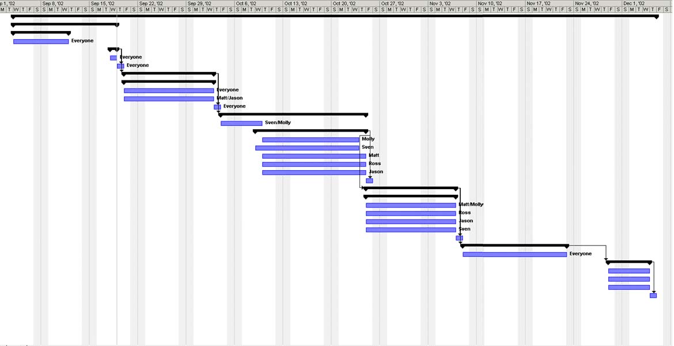

Task Assignments:
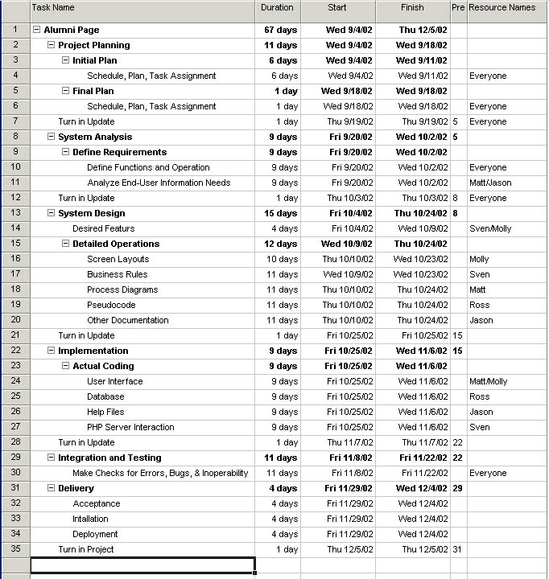

Process Flowchart:

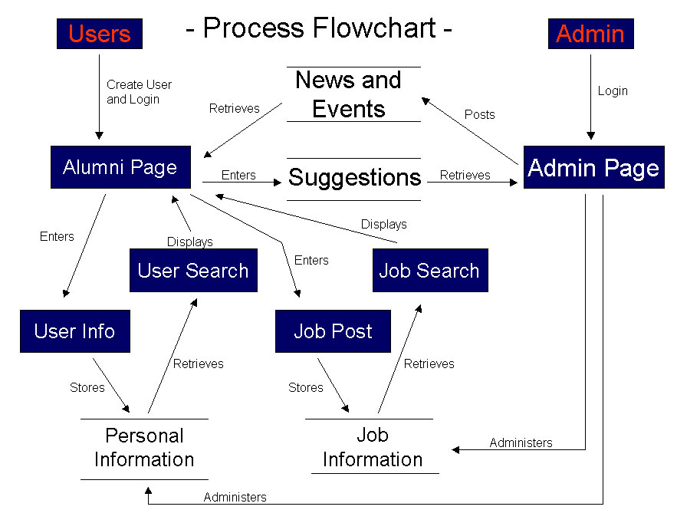

Process Diagrams
Example #1
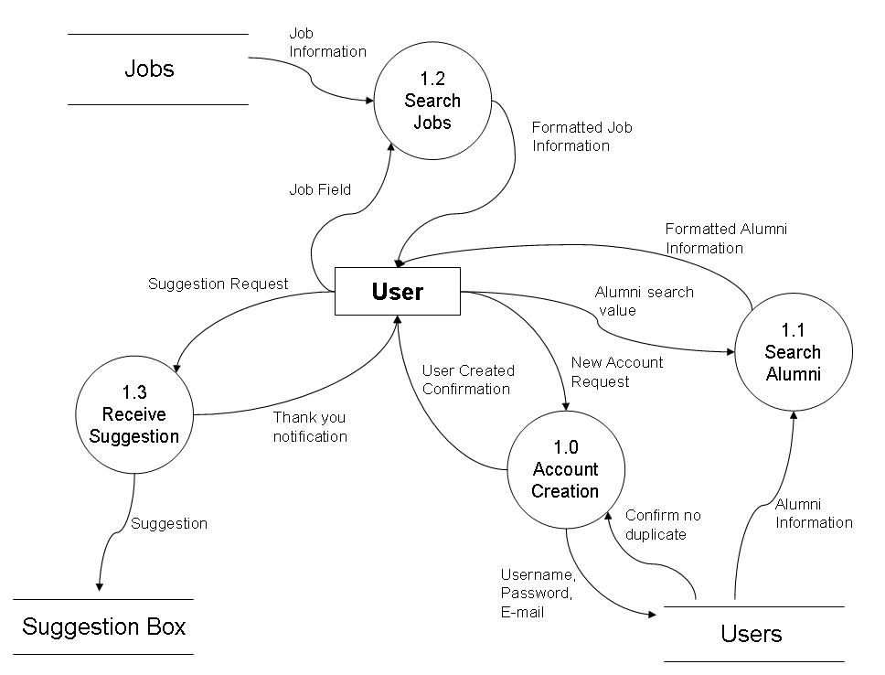
Process Diagram:
Example #2
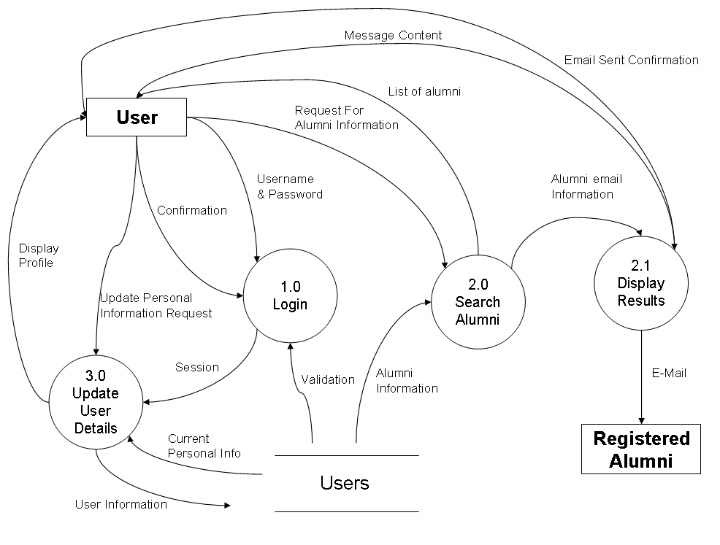

Process Diagram:
Example #3
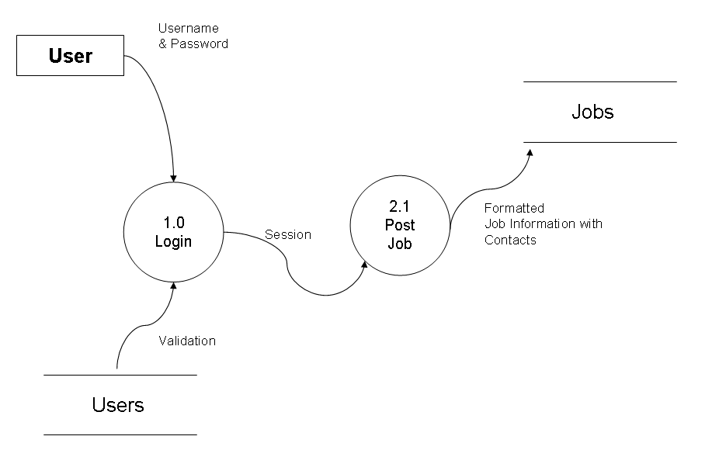
Process Diagram:
Example #4
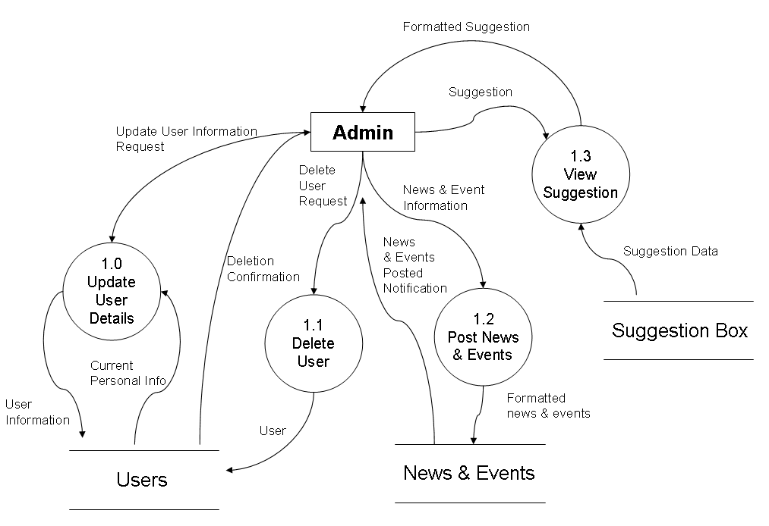
Entity Relationship Diagram:

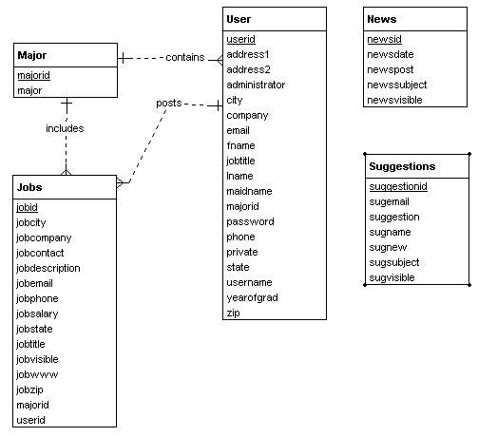

Software Engineering / Capstone

Florida Gulf Coast Alumni Page:
Final Project Report

Prepared for:
Dr. Nakatani

By:
Molly Howell, Jason McMillan, Matt Carpenter,
Ross Hedvicek, Sven Hahues

