Molly Howell
Matt Carpenter
Jason McMillan
Ross Hedvicek
Sven Hahues

Alumni Page Progress Report #2

This is the second report for the FGCU Alumni Page project. These reports are intermittent hand-ins, to document the work we have done on our project and how we progress through the stages of the development of our software.
This report will encompass the business rules, process diagrams, screen layouts, and some other design documentation that we felt necessary to be included with this project.

Business Rules:
The business rules we decided to use were the kinds of users we will have for this website. Depending on the status of the user, they will have different permission on the website. We identified three groups of possible users.

- Unregistered user/registered user who is not logged in:
Users of this class can either create a new account or log in so they can move to the second kind of users, which will be discussed next. These kinds of users will be able to browse the Alumni website and submit suggestions, as well as search for job information and other Alumni.
- Registered user who is logged in:
Registered users that are signed into the alumni page have all the right unregistered users have, except the site offers more functionality to them. If they searched for other alumni, they can now send an email to other alumni through the alumni website, to protect the email address of other alumni. Furthermore, they can fill out their personal information, so that other alumni can find them when searching through the list of alumni. While filling out their personal information the alumni has the ability to hide their personal information from being displayed in the search result. If the alumni choose to hide his or her personal information, only the year of graduation, major and current state will be displayed along with their last name and first name. Once the personal information are entered, the user can go back and edit them whenever they see fit. They will also have the ability to post jobs that will be sent to the administration for review and then possible posting. Finally, if this kind of user decides to submit a suggestion using the suggestion box, their personal information will be filled in based on availability; at least the email address will be supplied since it is required during signup.
- Administrator:
The administrator to the site has all the functionalities of the other 2 sets of users, and more. Administrators will be able to see all the suggestions sent through the suggestion box, they will see all the job information submitted, and they will have access to any users personal information, the ability to edit and change these as they see fit, the ability to add/remove news and events to the site as well as deleting users from the database.

Process Diagrams:
The purpose of these diagrams is to model the flow of data through the system’s major processes. The following three diagrams give an example of what a user can do when they are not a registered member of the alumni page and they can do when they are a registered member.

Example 1 – Unregistered Member:
If the user decides not to log in, they will have the option of searching for other Alumni. At the search page they will be asked to enter information about the Alumni they are looking for, these information can be, major, year of graduation, last name, first name or maiden name in case that specific person may have gotten married since they graduated. The submitted information will then be checked against the database and the information will be displayed on a results page.
If the user decides to browse through the jobs that are available they can do that in much of the same fashion that they used to search for other Alumni. Once again, the user will be asked what job field they are interested in, and those information will be checked against the database, and results based on the query will be displayed on the page.
Moreover, the user will also be able to send suggestions to the administration. This part is not covered in the diagram, but explained here for clarification. Any user of the website will be able to send a suggestion through the “Suggestion Box” feature of the site. This is done by filling out a form on the Suggestion Box part of the page which requires the user to leave their first name, last name and email address, so that they can be gotten in contact with in case there is need. The suggestions will be displayed on an administrative part of the page that only the administrator of the site has access to. The administrator can then make a decision on what to do with the suggestions, and forward them to the appropriate people.
An unregistered member of the Alumni page will be able to create a User Account to log into the Alumni Page to take advantage of its full capability. The process of signing up as a new member, asks the user for a username and password, as well as an e-mail address. Upon entering the data, the information will be checked for validity, and the username will be checked against other member names to make sure there is no duplication of this. If the data check is complete and there are no complications, the user information is stored in the database, and can then be used to log into the actual website.

Example 2 – User is registered and logged in
Once the user has created an account they can log in. Logging in will give the user another set of options that can not be seen by users who are not logged on. The user will have all access rights an unregistered user has and the added features they can from registering.
The user will now have the chance to enter their personal information. The personal information consist of first name, last name, address, employer, current job held, e-mail address (though required for account creation, e-mail address can change like street addresses and are therefore included again), major or date of graduation. This page also allows the user to choose if they want to keep their personal information private from other users. For the user’s convenience, once the information is filled in, upon subsequent return to the page, all information, except the password will be filled in for them. Once all the information is entered into the form, it is submitted and stored in the database.
In addition to the regular search feature, users who are currently logged in, will have the ability to send other registered Alumni e-mail through the website. The website will automatically fill in their e-mail address, and hide the intended recipient’s email address for further protection of privacy. The mail will then be sent through the web servers e-mail capability and received by the other party just like normal email.

Example 3 – User is registered and logged in
This diagram illustrates that a logged in user has the ability to enter job opportunities. This will be done via another form that is only accessible to logged in members, who will send the information about a job to the administrator who will then make it available to all users. This is done so that no one can post bogus job information and to keep things organized. It will be the administrator’s responsibility to reply to the user who offered the job, and acquire additional information about the job.

Example 4 – Administrator
The administrator of the site has even more functionality than any other kind of user. Once the administrator enters the administrative area of the alumni page, they will have the ability to update any users’ record, as well as delete users’ records, in case there has been abuse of the site by someone and that user shall have his account revoked. In addition to that, the administrator will have an area of the page where they will be able to view all the suggestions that were sent through the suggestion box. If any of these suggestions warrant action, such as a post in the news section, or an e-mail forward to another FGCU faculty member, it is the administrator’s responsibility to take the necessary actions. Finally, the administrator can post news and events that will be displayed for all users. To do so the admin will simply go to the post news and event section of the website and fill out the form that will automatically post the news on the website.

Other design documentation:
Other documentation that is used to a great extend of this project are the Florida Gulf Coast University Web guidelines that are a requirement for any website that will be officially hosted by FGCU. The only change we made to these policies is the exclusion of a text-only site. We are in touch with David Jaeger, who is in charge of the FGCU web development, and he gives us feedback on what we need to change to make the site compliant with FGCU standards. A copy of all the web policies can be viewed online at: http://itech.fgcu.edu/web-policies.asp

Screen Layouts:
So far we have completed 90% of the user HTML pages, once we completed the layout of all the pages, we will build the relational database, and start writing the code behind the HTML to make it work.
The HTML pages that represent the way the page will look can be found online at http://student.fgcu.edu/shahues/capstone/layout/ .
Process Diagrams
Example #1
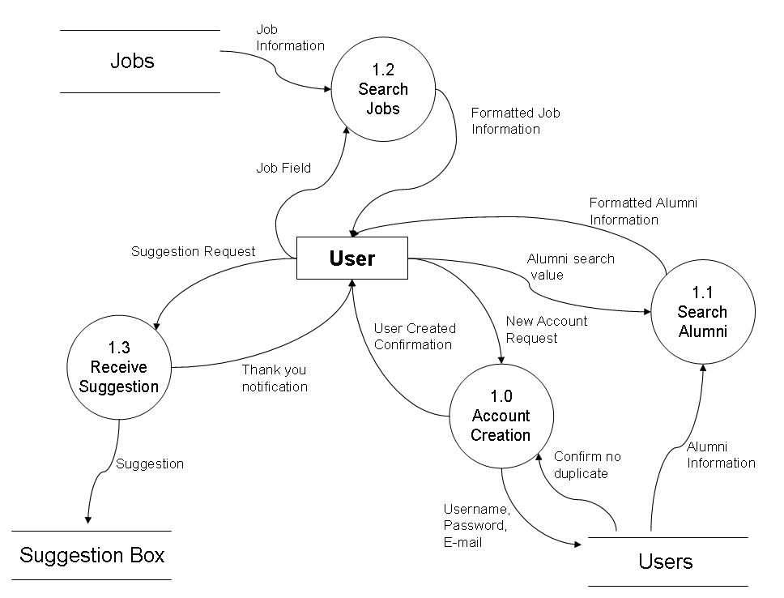
Process Diagram:
Example #2
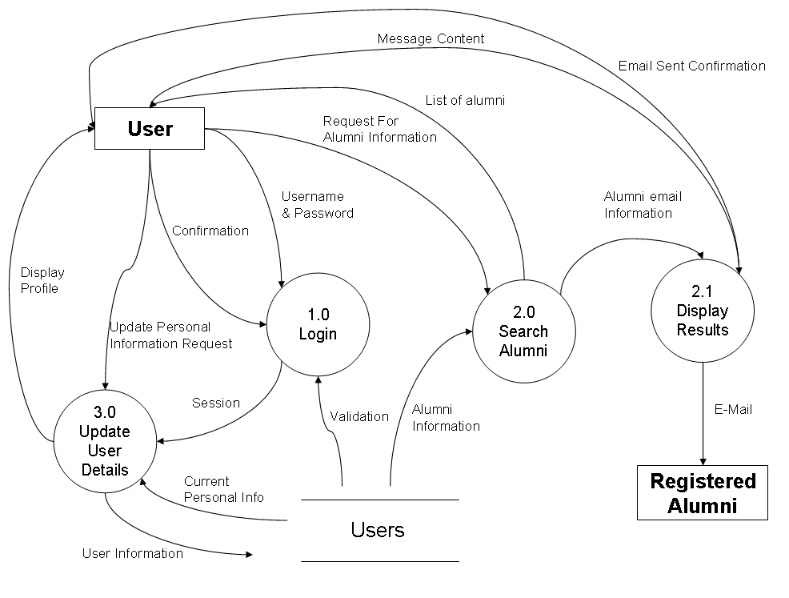

Example #3
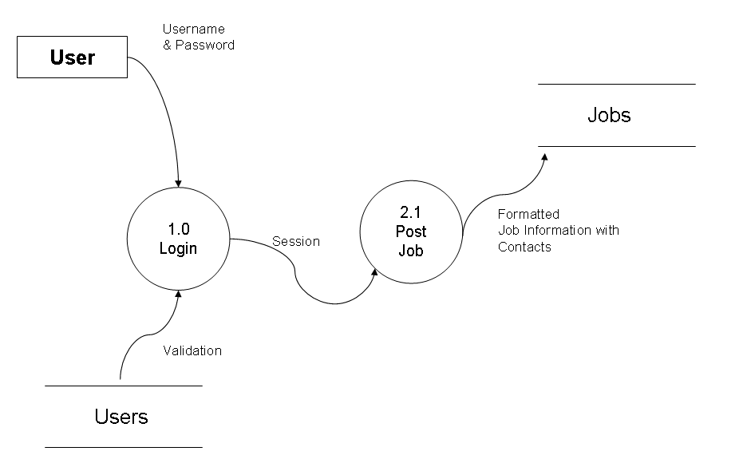
Example #4
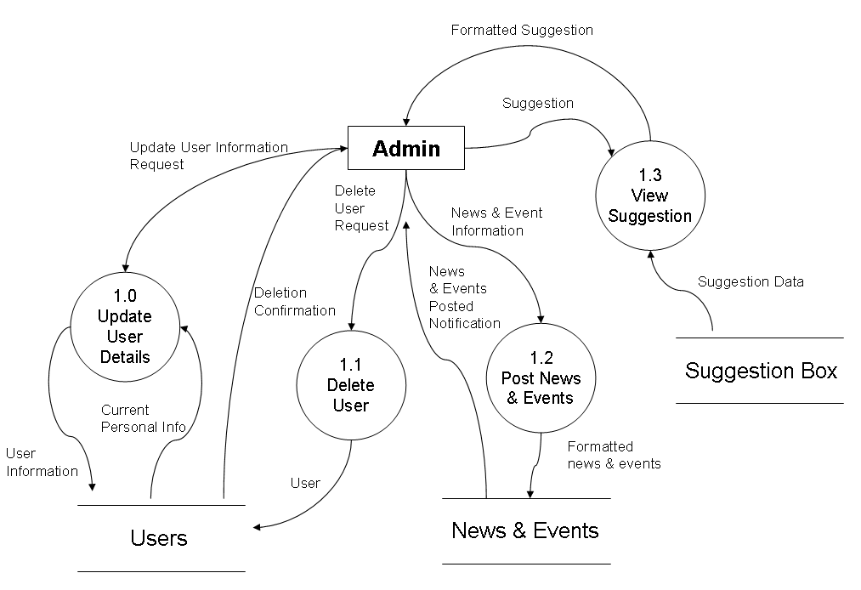
Software Engineering / Capstone

Project Progress
Report #2

Prepared for:
Dr Nakatani

By:
Molly Howell, Jason McMillan, Matt Carpenter,
Ross Hedvicek, Sven Hahues

