Group 3
Molly Howell
Ross Hedvicek
Jason McMillan
Matt Carpenter
Sven Hahues

Software Engineering – FGCU Alumni Website

Description of the project:
The FGCU Alumni Website will allow people who graduate from Florida Gulf Coast University to keep in touch with people who they went to school with. Furthermore it will be a place to post news about ongoing and upcoming events of FGCU alumni, and a place for them to interact with each other, as well as keep in touch.
In addition, the website will allow the departments and alumni to post job opportunities for other alumni to see. Furthermore, there will be a suggestion part of the website, where alumni can submit suggestions, such as university sponsored get together, to the university. The users will be able to create an account with a password that they will use to log into the system. Once there they can fill out their contact information and share whatever they would like to with other alumni to protect their privacy. The users information will not be used for any kind of commercial use, they will strictly be used for the alumni association.

Purpose of the project:
The purpose of this project is to create a small community where FGCU alumni can reunite, share information and look at job opportunities.

Current System:
Right now there is no system in place for this. A list of all the graduates from a department is held at the department, and if there are events within that particular department, the department will contact their alumni themselves.

Problem Statement:
There is no central place for FGCU graduates to go right now. After graduation, graduates have no way to keep in touch with old classmates, other than the information they have themselves. The ways of organizing events right now are hazy and it is hard to reach out to every alumni.
Furthermore, departments such as the College of Business, only maintain records of their own graduates, so if there were to be a get together of all alumni, sponsored by the CoB, it would be very time consuming for them to get in touch with every alumni from every department. In addition, there is no way for the University to easily get in touch with every alumni that ever went to school there, which makes building a culture and sense of community and belonging harder for the university.

Scope:
- Description:
Create an easy to use website for FGCU graduates, to have a place to share information on where they are, how they are doing and listing of possible job offers.
- Benefits:
Improved communication between alumni and faculty
Inexpensive implementation
Improved time efficiency of information distribution compared to the current system
Combination of several manual tasks into one central location
- Duration of the project:
Final project hand in will be December 5, 2002

Systems Development Lifecycle to be used:
We will be using the incremental SDLC approach. Our reason for doing this is, that we will do several small steps until the project is completed. It will be much more manageable and easier to handle this way. At first we will start with the server setup then the database design and then start with the actual coding of the website.

Technology used:
The website will be hosted on an “apache” web server running Red Hat Linux v7.3. The database we will use for this system is PostgreSQL, a open source database that is included in this distribution of Linux.. The reasons for running Red Hat are: discovery of a new operating system, use of a web programming language other than ASP (PHP will be the programming language that we will use), Linux and PostgreSQL are free, so there will be no added software cost to this project. It will be hosted on a privately built server until completion at which time the university will take over the project.
The reason for using PostgreSQL over MySQL is that PostgreSQL is a little bit more scalable towards supporting more users. It is slightly slower than MySQL, but it supports more users that are simultaneously logging into the database.
All our team members have done web programming before, which is the primary reason we choose this project. Furthermore the setup and administration of a web server will be done by us for the time being. The server is accessible to all team members at most times of the day.

Business Constraints:
There really won’t be too many constraints. Not all of us have used php as a programming language, nor are all of the users familiar with Postgres and Linux, yet we are confident that we can overcome this, and learn both these in a relative short time. The budget of this undertaking is negligible, as all the software is free and the server was built out of old computer parts.

Possible Conflicts among stakeholders:
If not done to university standards the system itself will fail, as the university will very likely reject the use of it.

Users and Owners of the system:
The primary users of the alumni page will be all the alumni who graduated from FGCU, and the faculty and staff who instructed these students. The system will be administrated by a person who volunteers to take the time to update the news and events on this page. The administrator also has access to all the user information and can modify them if they see need. The administrator also has the right to delete user accounts. The University will be the owner of the system once it is completed and accepted.

Cost - Benefit analysis:
The costs of this project will be minimal, as it will be run on Linux, using an open source database and php to access the database. Once completed, the system should not need a lot of maintenance.
The benefits of the website far outweigh the costs, as this will be perceived as an effort to build a community of alumni. The benefits can range anywhere from a good culture among the graduates of FGCU to donations for alumni programs and events.

Milestones:
All milestones are detailed in the task assignment. Significant milestones are as following:
September 19, 2002 - Final Plan
October 3, 2002 - Update of System Analysis
October 25, 2002 - Update of System Design
November 11, 2002 - Update of Implementation Process
December 5, 2002 - Completion of Project

Schedule:

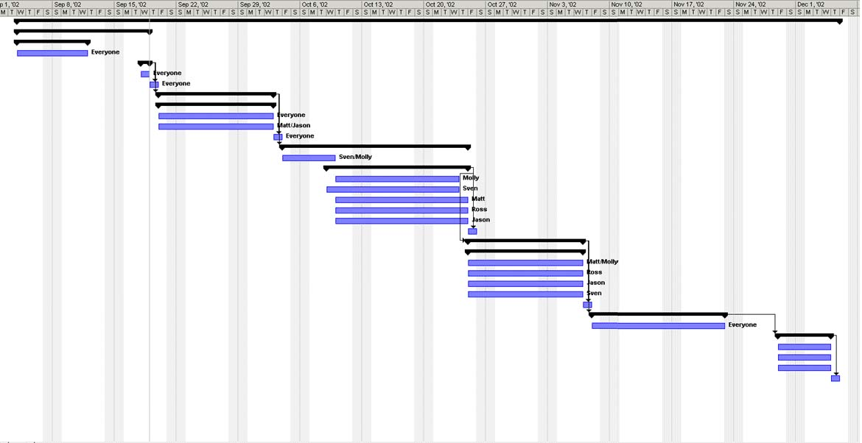

Task Assignments:
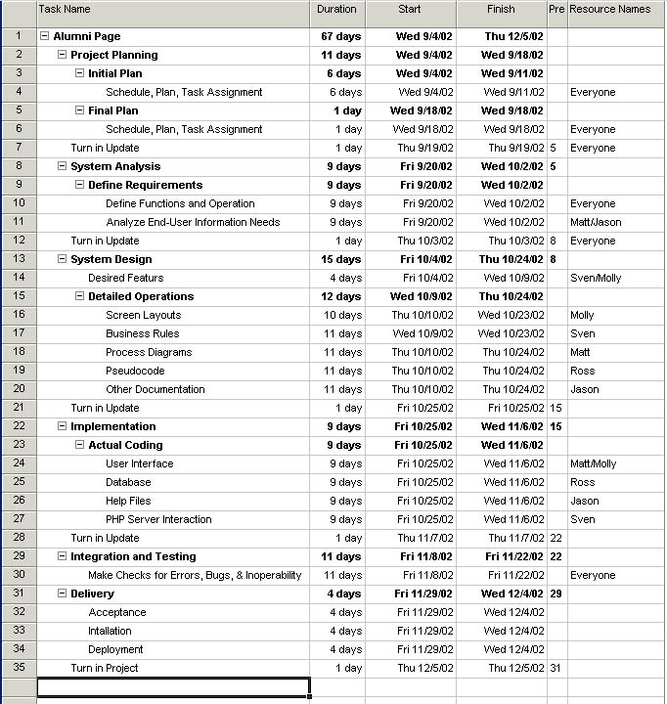

Process Flowchart:

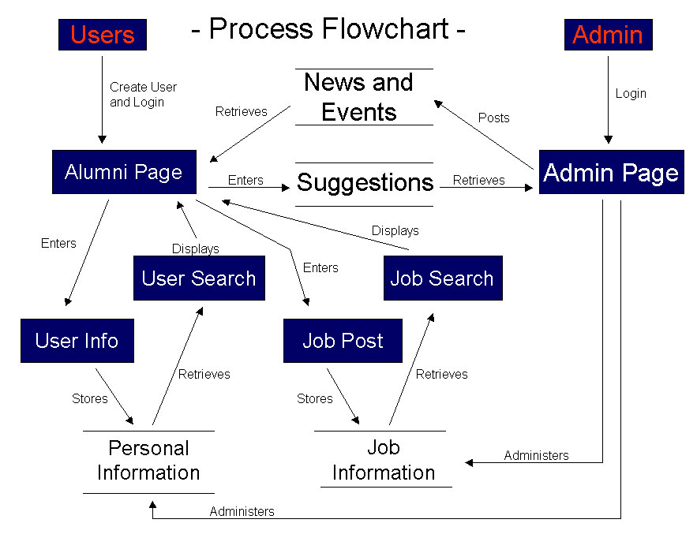

Change request form:

Change Order Form

To request any changes about the proposed project please write a detailed description of what you would like to have changed below and hand it back to the group for review.

________________ __________
Signature Date

